**JAVA-8 ASSIGNMENT-1**

Q1) Write the following a functional interface and implement it using lambda:

* To check whether the first number is greater than second number or not, Parameter (int ,int ) Return type boolean

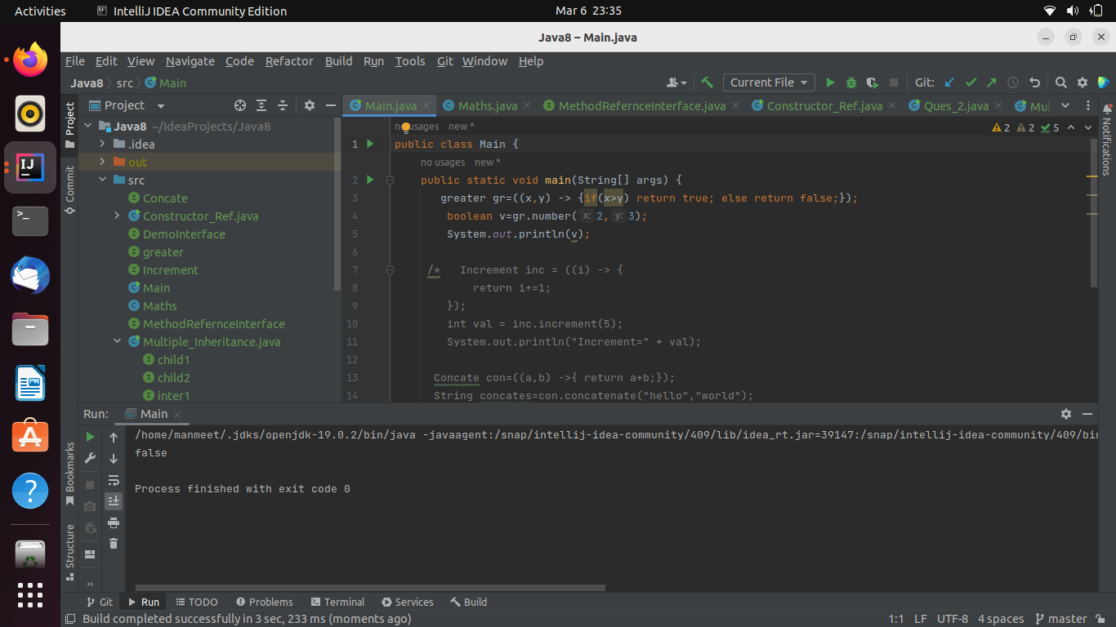

* Increment the number by 1 and return incremented value Parameter (int) Return int

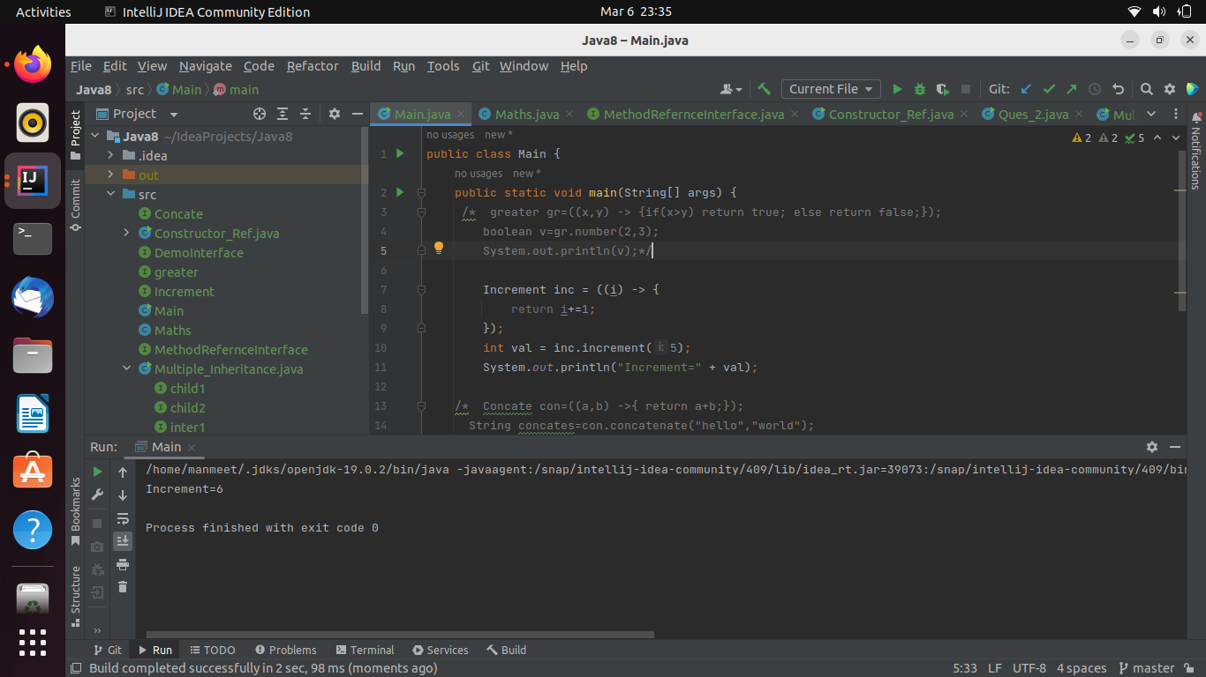

* Concatination of 2 string Parameter (String , String ) Return (String)

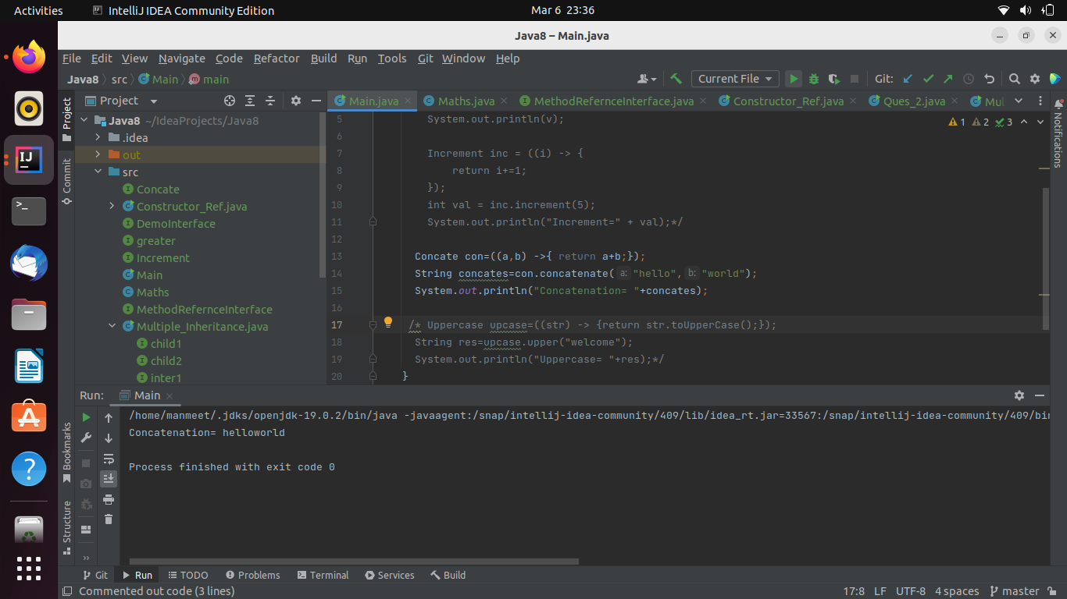

* Convert a string to uppercase and return . Parameter (String) Return (String)

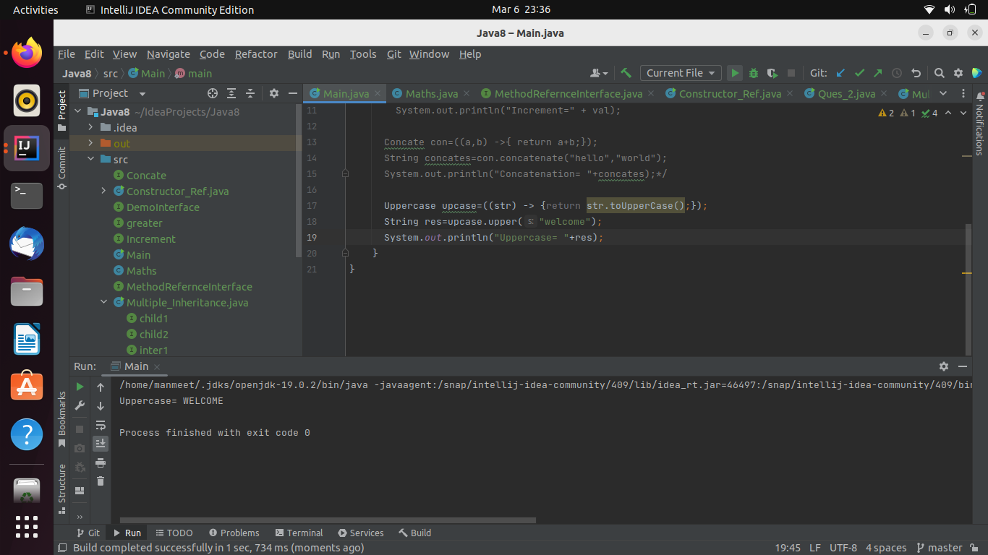

Q2) Using (instance) Method reference create and apply add and subtract method and using (Static) Method reference create and apply multiplication method for the functional interface created

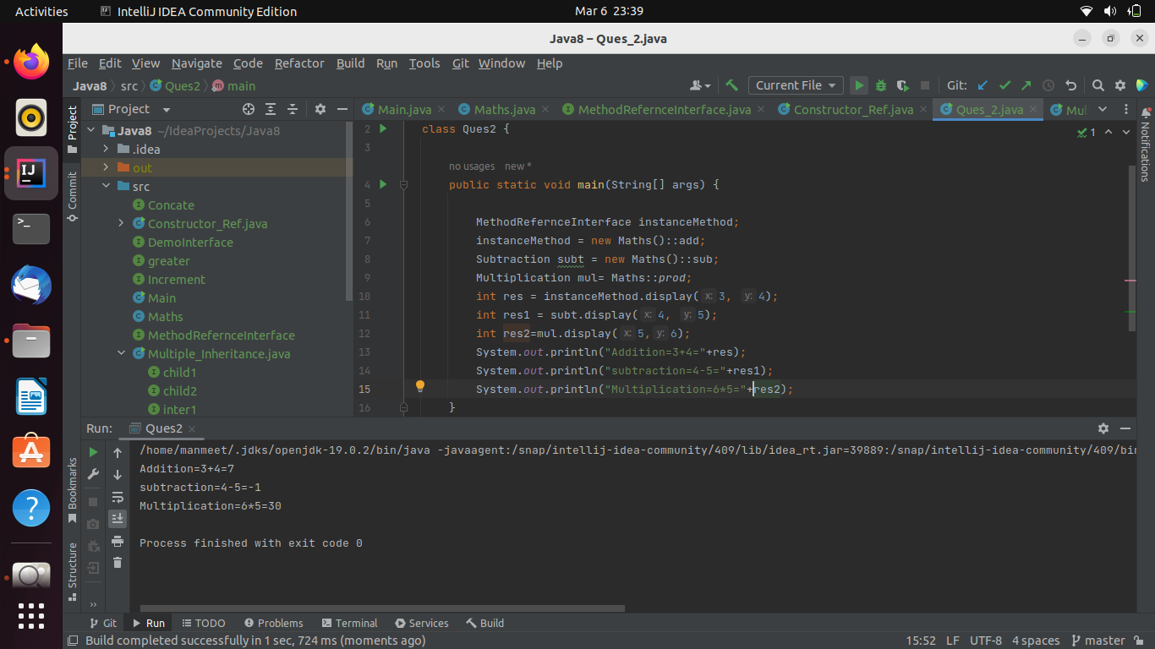

Q3) Implement multiple inheritance with default method inside interface.

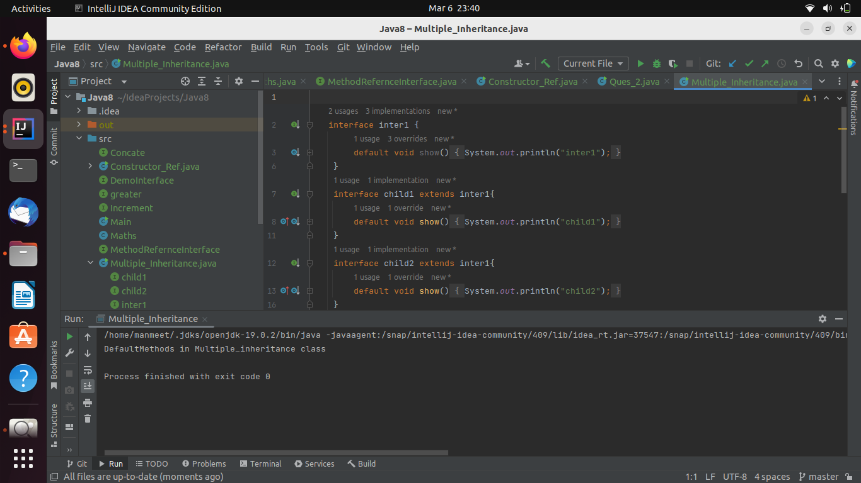

Q4) Write a program to implement constructor reference

